 | The School of MOVES
 | About the Artist
 | 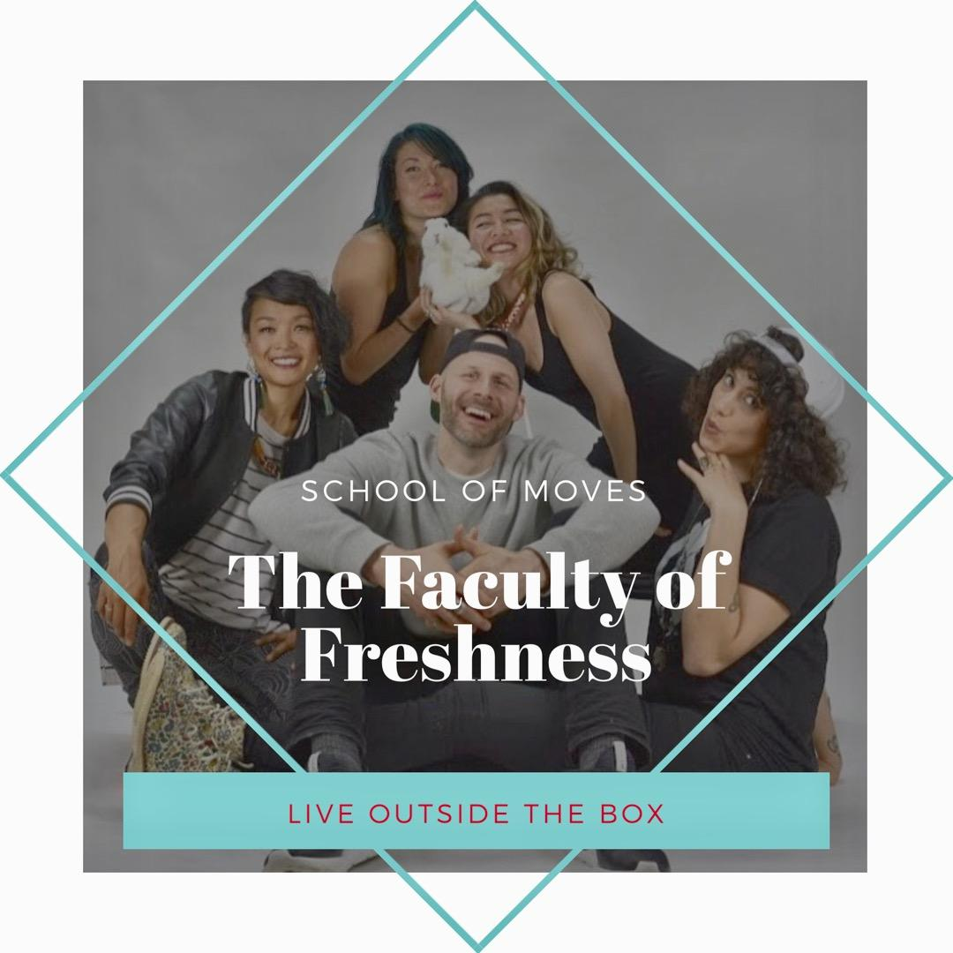 | The School of MOVES is a mobile school for self-discovery founded by DiANNA DAVID, a Movement Storyteller and long-time youth entertainer and arts educator. As she wanted to take learning wherever she goes, DiANNA built a crew of self- motivated artistic leaders called The Faculty of Freshness to spread their fresh perspectives on how they live their artforms in life.  Through storytelling & a unique workshop-style performance, these highly potent artists act as role models to inspire the youth to discover their potential too and to practice fun tips to become the best Conscious Creative Kids they can be. No matter how old they are because learning is an ageless thing!
 | About the Performance
Our 60 - 90 minute workshop-style performances are mainly booked as duos, featuring each Faculty's
specialty topic - Movement Storytelling, Prop-Play, Voice Empowerment, Sign Language, Animal Whispering and Acting. Each show is uniquely customized to focus on our Faculty’s integrated art practice, performed through inquiry based learning techniques, considering core competencies of the show’s targeted grades.

Using creative expression by experiential learning, our self-discovery builds strong character and high levels of self-esteem that can take us anywhere and be the creative solvers to our world problems.

Students are asked to participate, some will come up and showcase and many will be asked interview questions throughout the show.

Options for solo talks, large group events or 1-5 Day Artist in Residencies are available upon request.

WEBSITE: www.schoolomoves.com
 | About the Art Form
We believe that everyone is an Artist and it comes from an attitude of curiosity, play and making moves that matter to you. We can create our situations just by being aware of our surroundings and learn to PLAY, PRACTICE, PERFORM & PERSEVERE. If you work at the things you love, you will eventually live out your dreams.
- Watch: DiANNA DAVID’S TedxTalk “Have the Balls to Follow Your Dreams” on YouTube
 | Links to Curriculum
- Physical & Health Ed: “Knowing what we enjoy doing and knowing about our opportunities to participate in those activities helps us develop an active lifestyle.”
- English Language Arts: “Listening carefully helps us learn.”
- Arts Education: “Dance, drama, music and visual arts are each unique languages for creating and communicating.”
 | Pre-Performance Discussion Questions
Two or three questions for students prior to the performance:
- How do our senses help keep us curious and entertained?
- How do your thoughts affect the way you feel about yourself?
- What are the many different ways can we express ourselves (eg. writing, singing, body language, dance, sports)?
 | Post-Performance Activities
Two or three activities for students after watching the performance that have relations to the art form:
- 1) Describe the part of the show when you were most engaged and tell us how that makes you see your surroundings differently now. What will you try at home more often?
- 2) Make a handshake with a friend and every day add a new move to it. How long of a collaborative choreography can you make? How can a handshake be an unspoken language?
- 3) Close your eyes and have your teacher turn off the lights in your classroom. Then your teacher can prompt you to imagine as if you’re zooming into a portal. Make the sound effects and move in your chair on how you would get there. Once you’ve arrived, get your teacher to turn on the lights. Describe the portal to your teacher because anything goes. Then, each person can say one thing they can create in the portal that has never been seen before. How can this object help us and the world be a better place to live?
 | Post-Performance Discussion Questions
Two or three inquiry-based questions:
- 1) List at least 3 qualities in yourself you will need to keep learning fun?
- 2) What are different ways of solving problems if you get stuck or don’t have an answer?
- 3) If you got to know someone better, how do you think you would act around them?
Learn more about this artist online at artstarts.com/aotd

